Lesson 05 Lesson-End Project

Create an Application Gateway with Path-Based Routing

Project Agenda: To create an application gateway with path-based routing

Description: You are given a project to create an application gateway with path-based routing.

Tools required: Azure account with administrator access

Prerequisites: None

Expected Deliverables: Add a screenshot showing the created application gateway with
path-based routing

Steps to be followed:
- Create virtual machines
- Instal IIS
- Create an application gateway
- Test the application gateway

Step 1: Create virtual machines

- Sign in to the Azure portal and click on Virtual machines

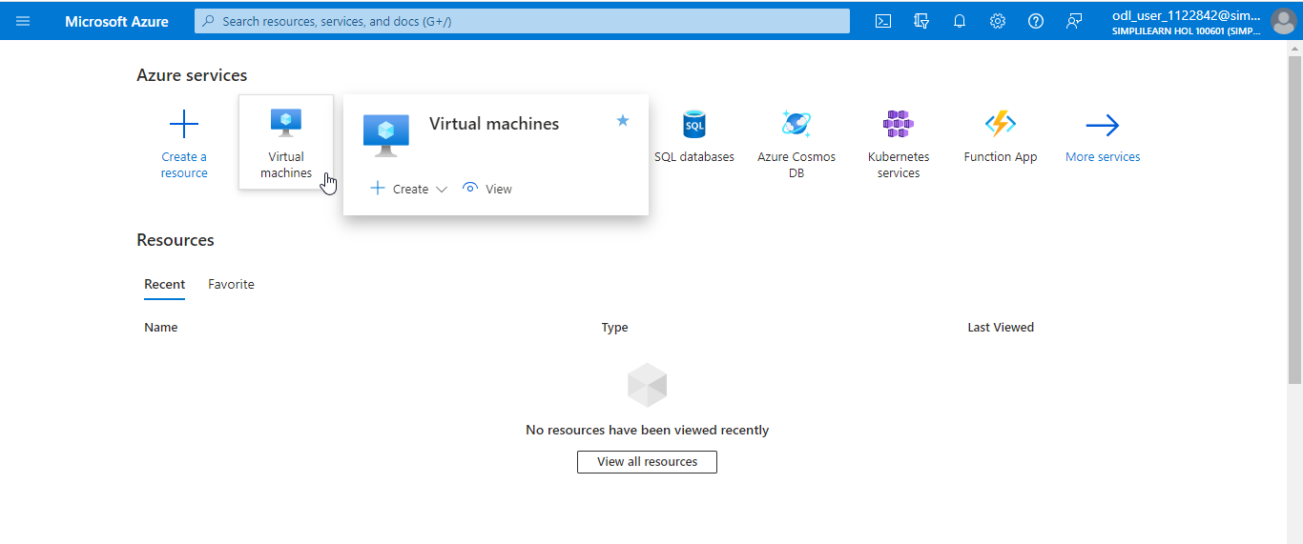

- In the Virtual machines page, select the + Create dropdown and click on Azure virtual machine (vm1)

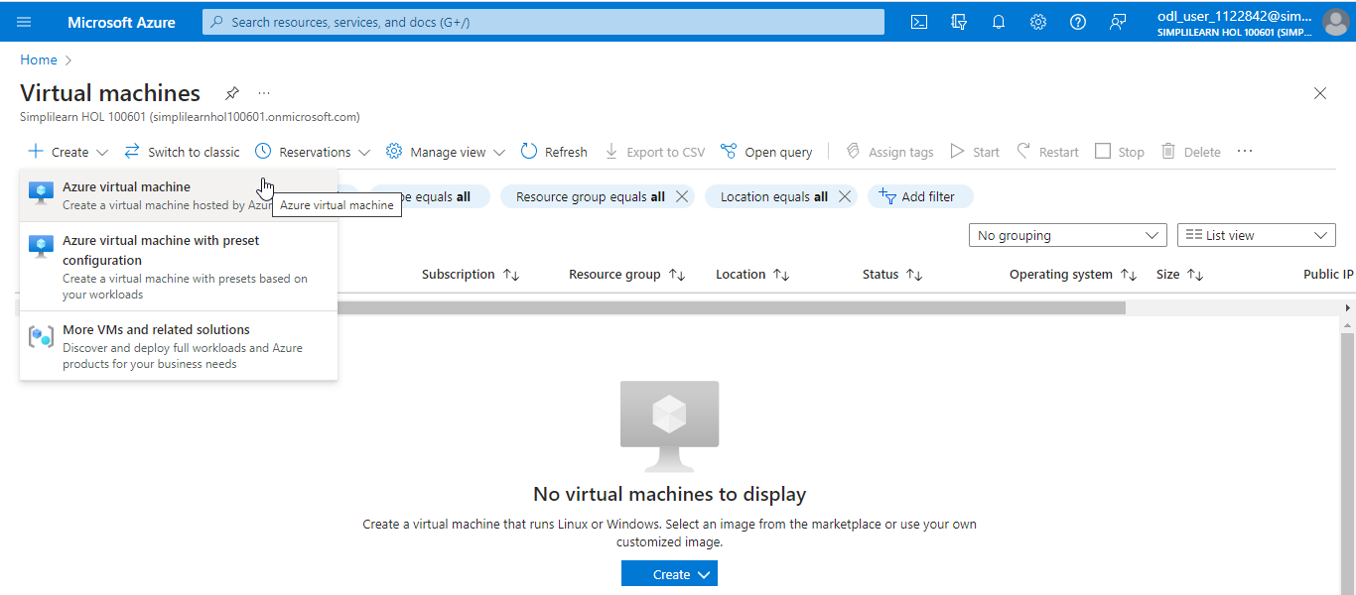

- Under the Basics tab on the Create a virtual machine page, click Create New to create a new Resource group

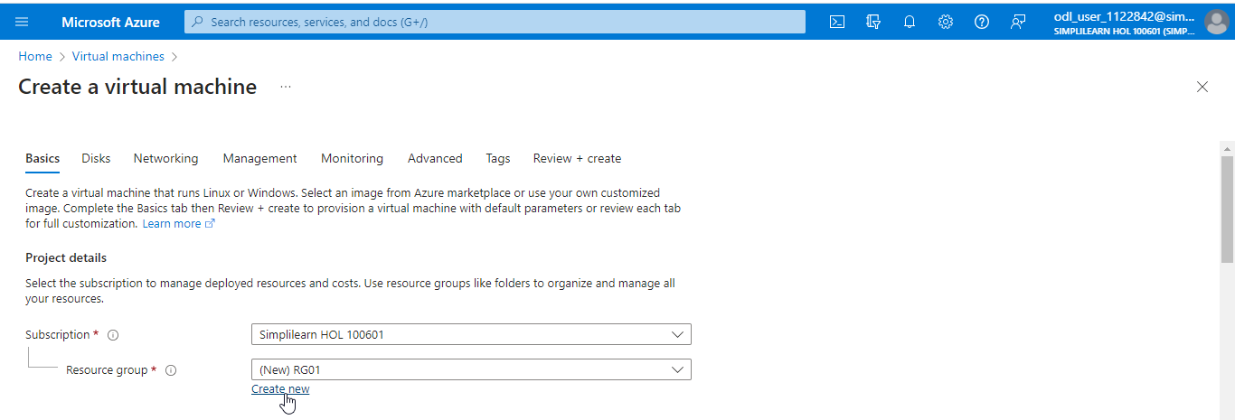

- Under Instance details, provide the details as shown in the screenshot below:

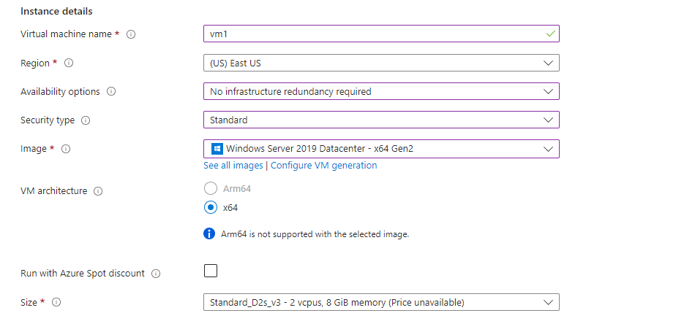

- Under the Administrator account, provide the details as shown in the screenshot below:

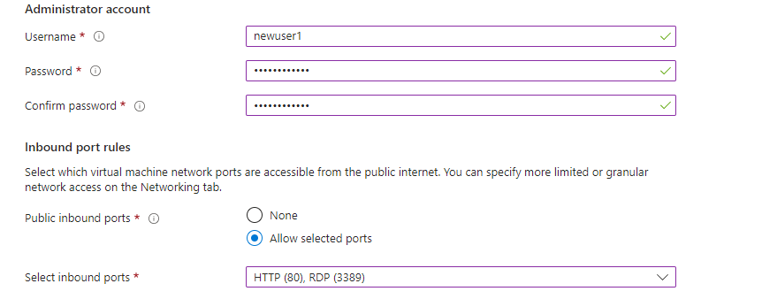

- Under the Disks tab, select Standard HDD (locally-redundant storage) for the OS disk type

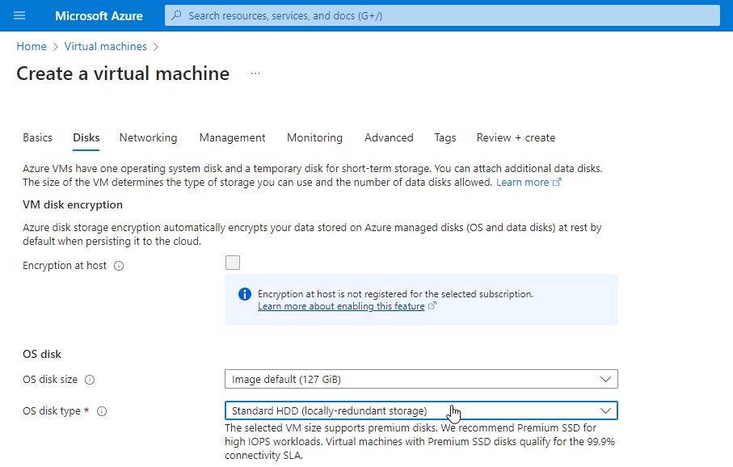

- Under the Networking tab, click on Create new to create a new Virtual network. Enter the details as shown in the screenshot below in the Create virtual network section. Now, click OK.

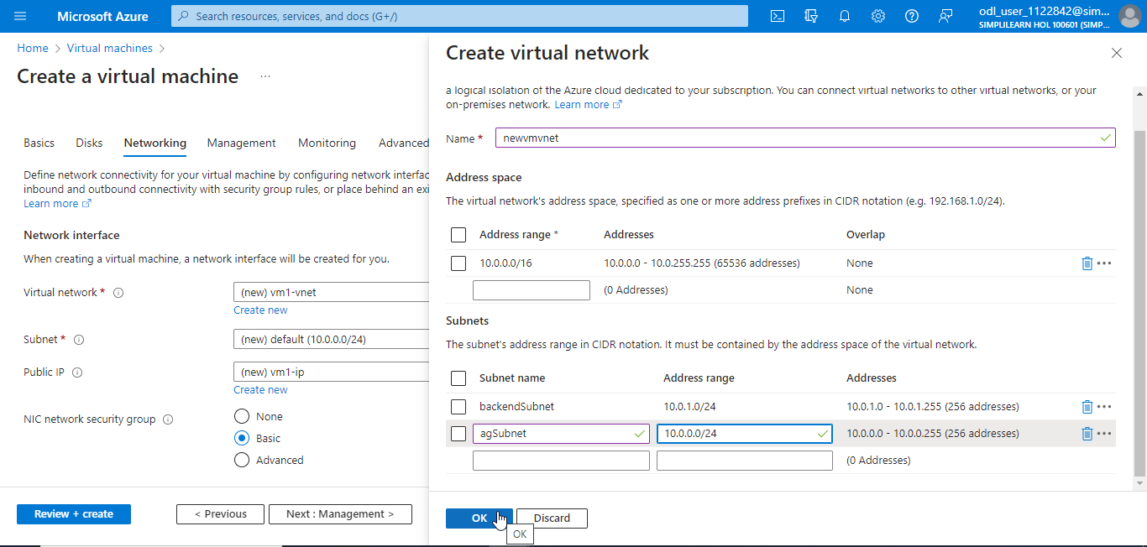

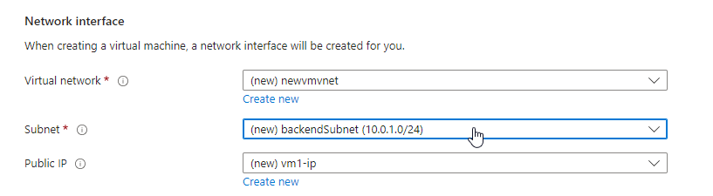

Note: In the Subnet, select backendSubnet (10.0.1.0/24)

- Click on Review + create

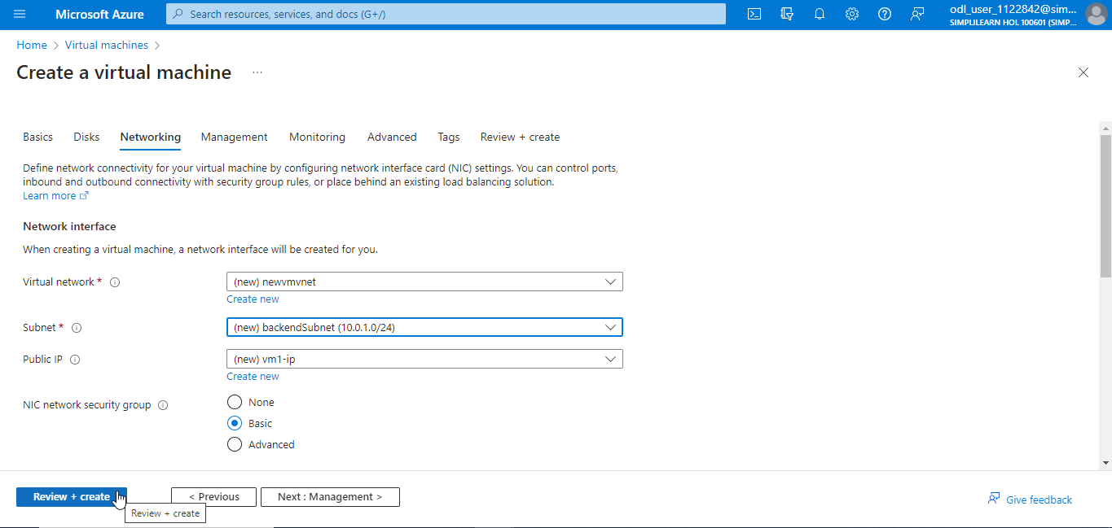

- Once the validation passes, click on Create

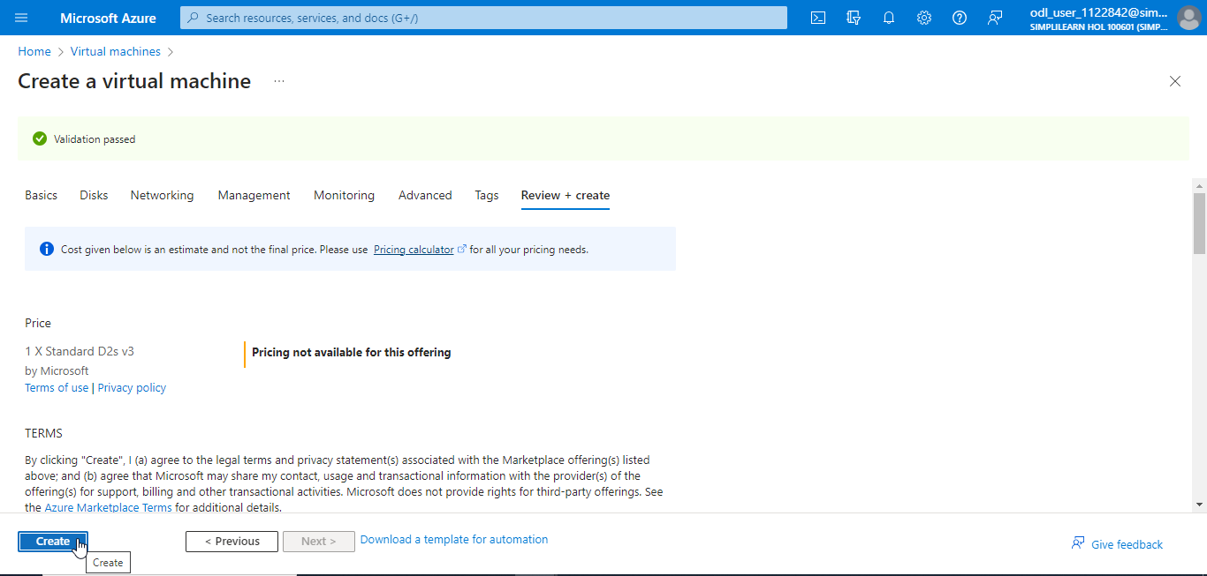

The output will look as follows:

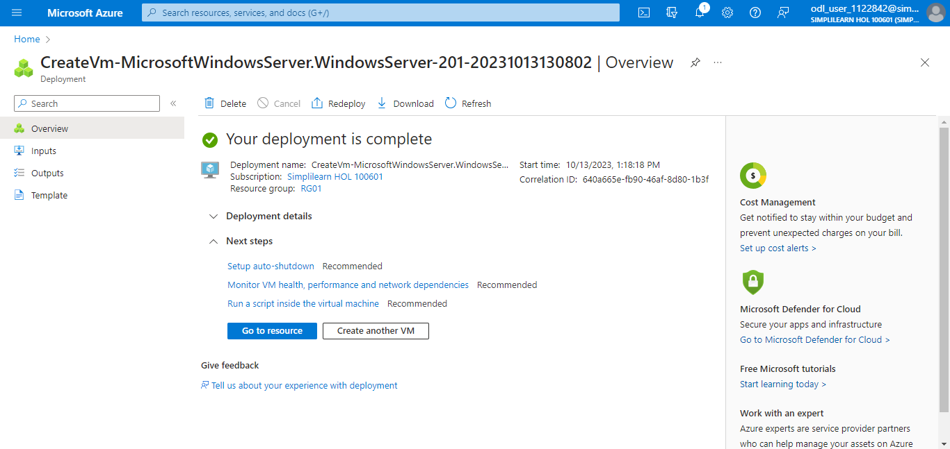

vm1 has been created successfully.

Note: Follow the above steps and create another virtual machine (vm2)

Step 2: Install IIS

  - Navigate to the Azure home page and click on Cloud Shell

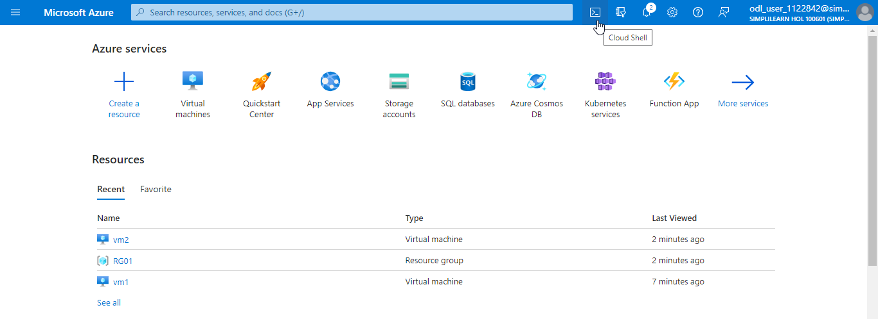

  - Select PowerShell

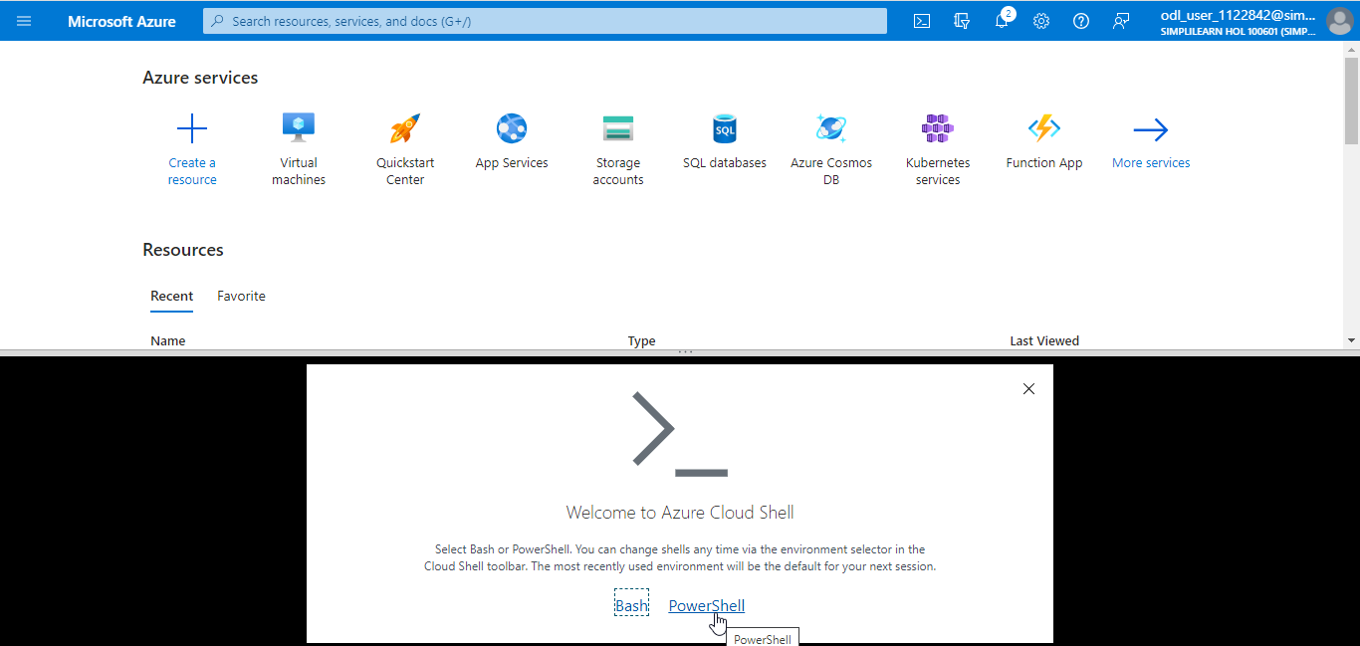

  - Click on Create storage to mount the storage

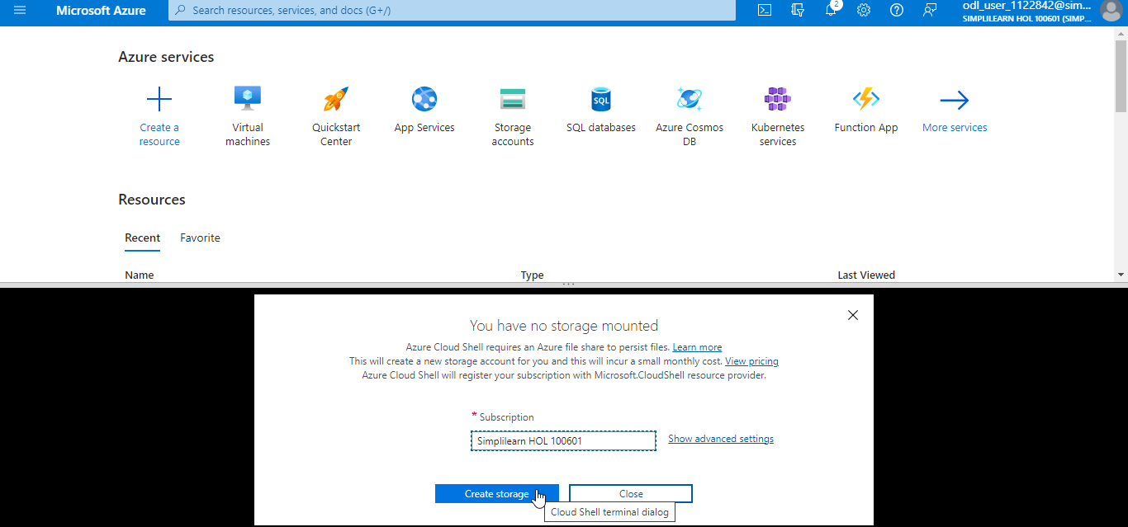

  - Enter the following code to install IIS in vm1:

$publicSettings = @{ "fileUris" = (,"https://raw.githubusercontent.com/Azure/azure-docs-powershell-samples/master/application-gateway/iis/appgatewayurl.ps1"); "commandToExecute" = "powershell -ExecutionPolicy Unrestricted -File appgatewayurl.ps1" }
Set-AzVMExtension `
-ResourceGroupName RG01 `
-Location eastus `
-ExtensionName IIS `
-VMName vm1 `
-Publisher Microsoft.Compute `
-ExtensionType CustomScriptExtension `
-TypeHandlerVersion 1.4 `
-Settings $publicSettings

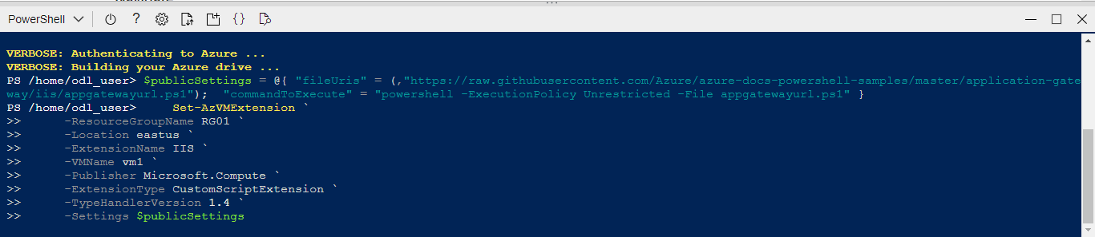

  - Once IIS is installed in vm1, the following message appears:

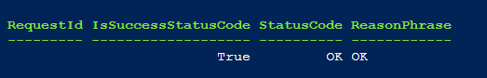

Note: Repeat the above steps to install IIS in vm2. Give the respective resource group name and virtual machine name.

Step 3: Create an application gateway

  - Search for and select Application gateways

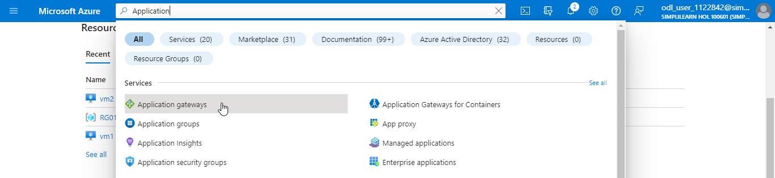

  - On the Application Gateway page, click on + Create

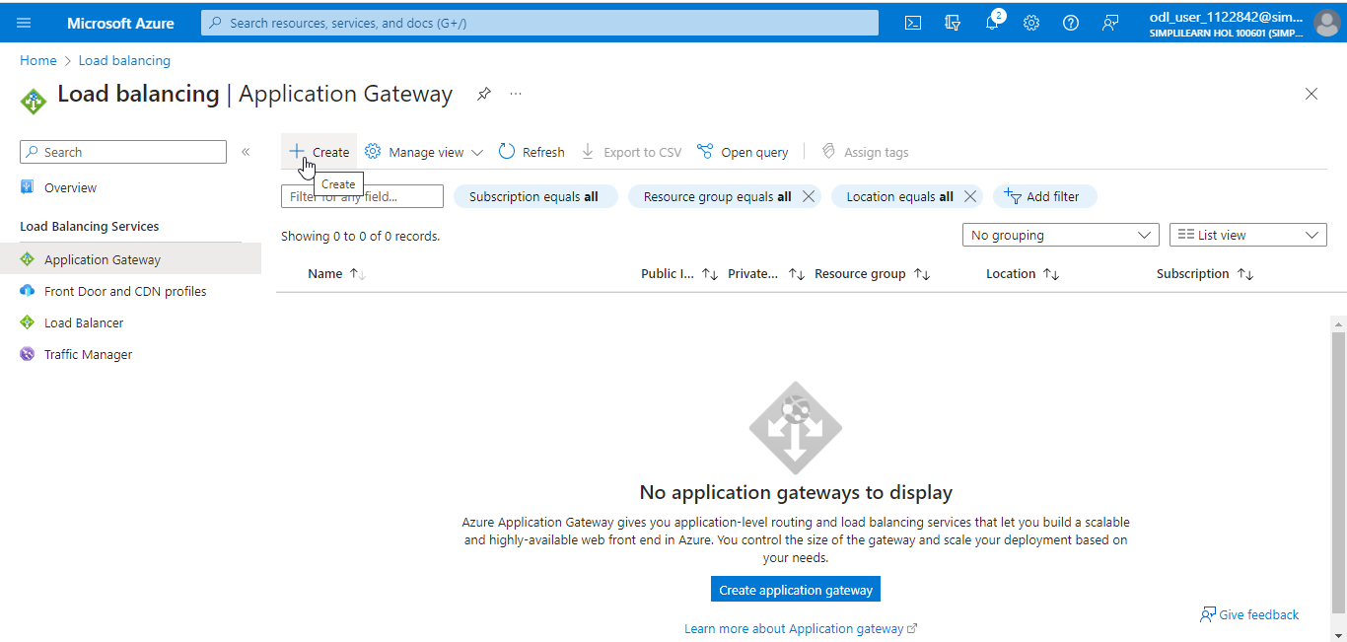

  - On the Create application gateway page, navigate to the Basics tab. Under Project details, provide the details as shown in the screenshot below:

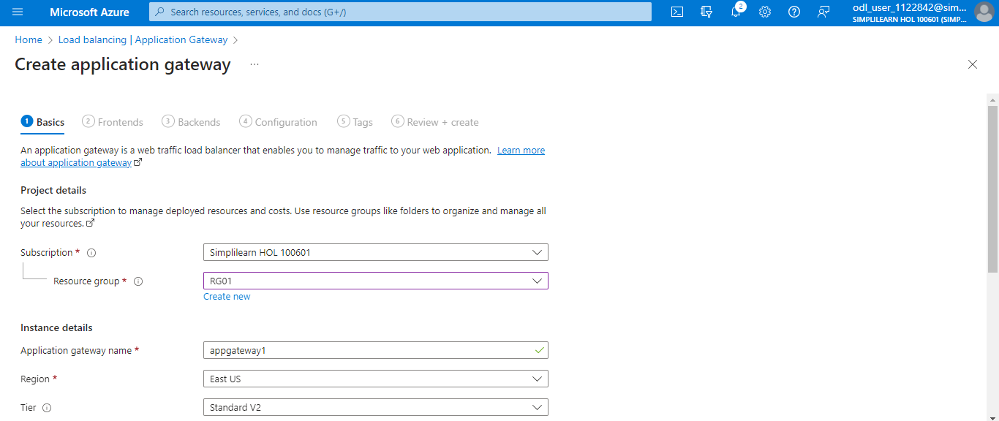

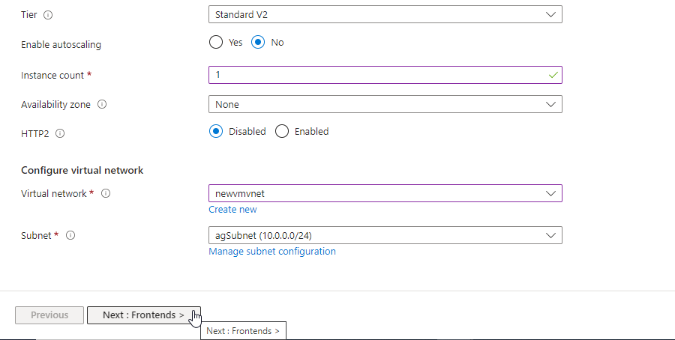

  - Under Configure virtual network, provide the details as shown in the screenshot below, and click on Next : Frontends >

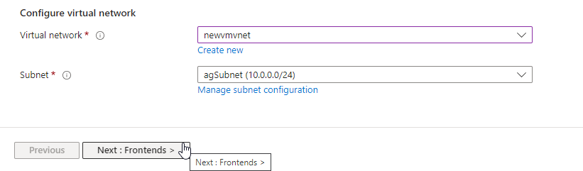

  - In the Frontends tab, navigate to the Public IP address and click on Add new

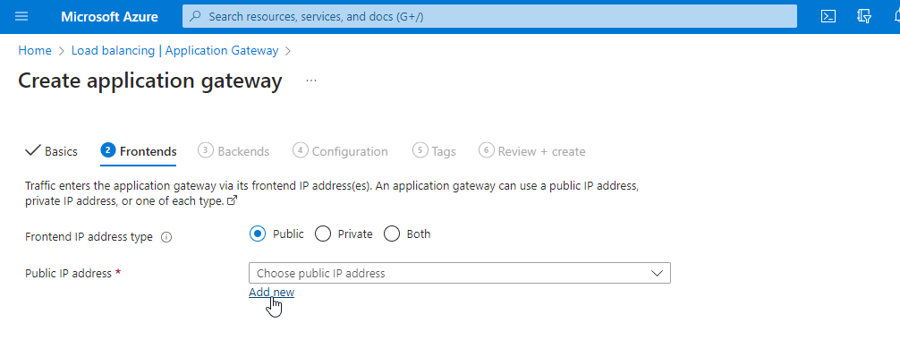

  - In the Add a public IP box, provide a Name and click OK

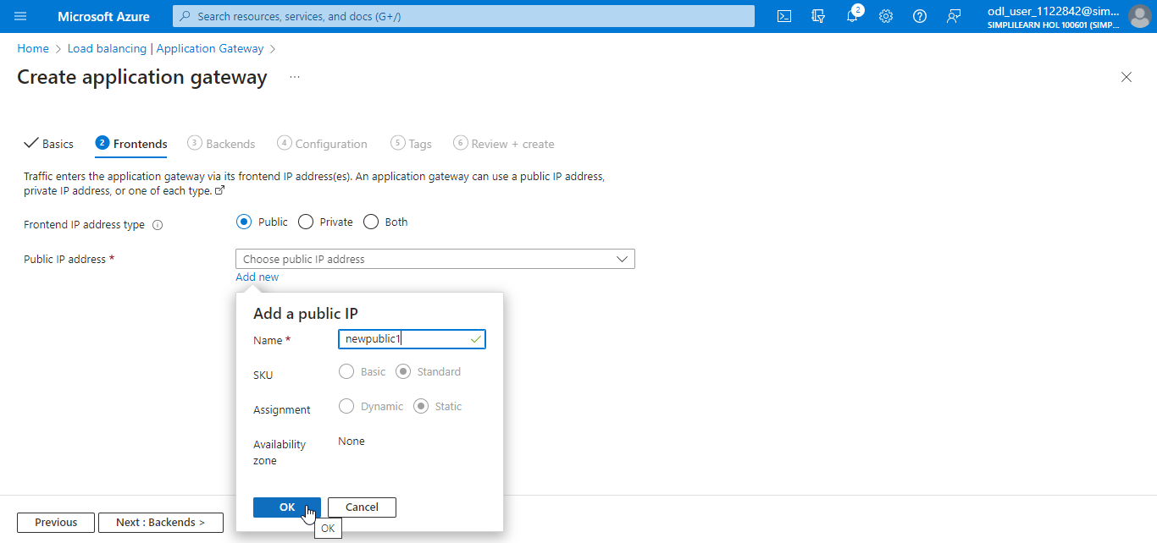

  - Click Next : Backends >

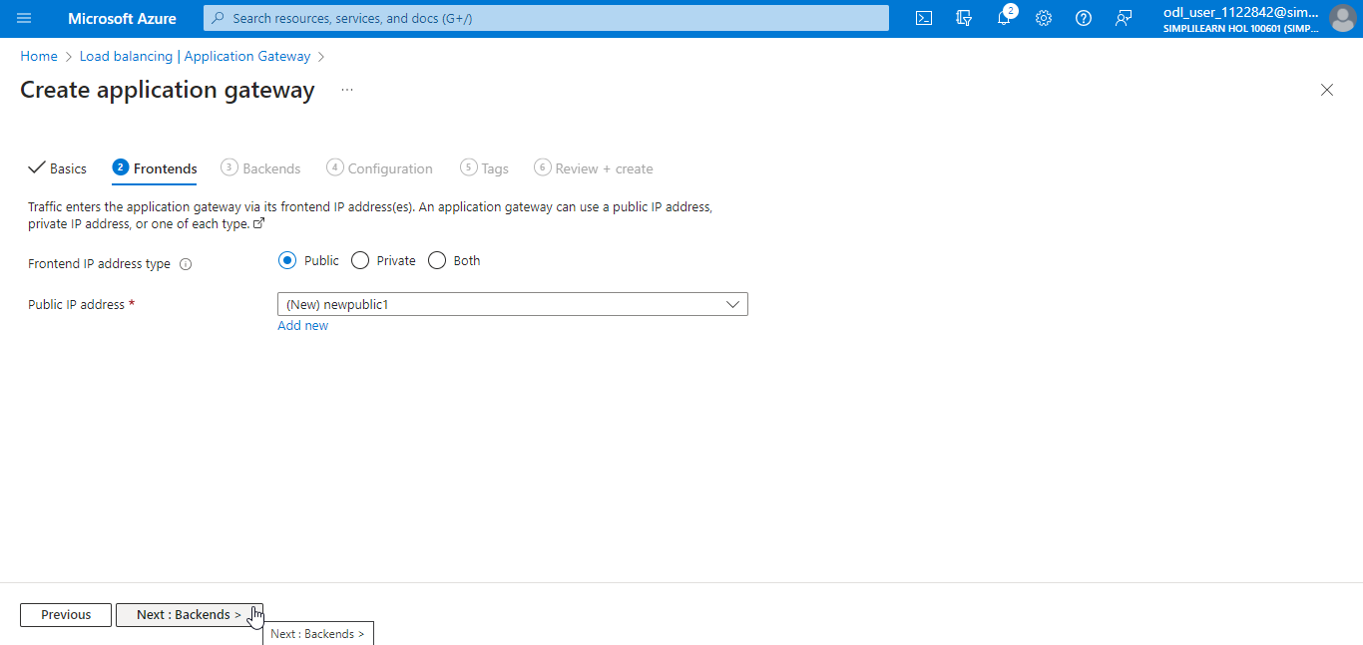

  - In the Backends tab, click on Add a backend pool

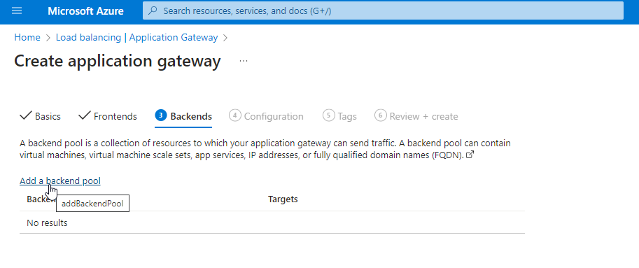

  - In the Add a backend pool section, enter a Name. Select Virtual machine under Target type, select the virtual machines as Target, and click on Add.

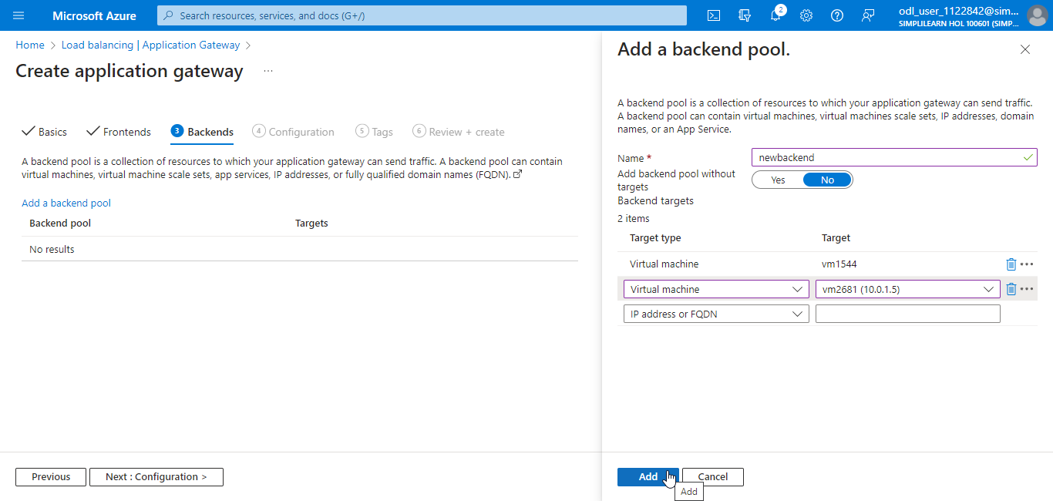

  - Click Next : Configuration >

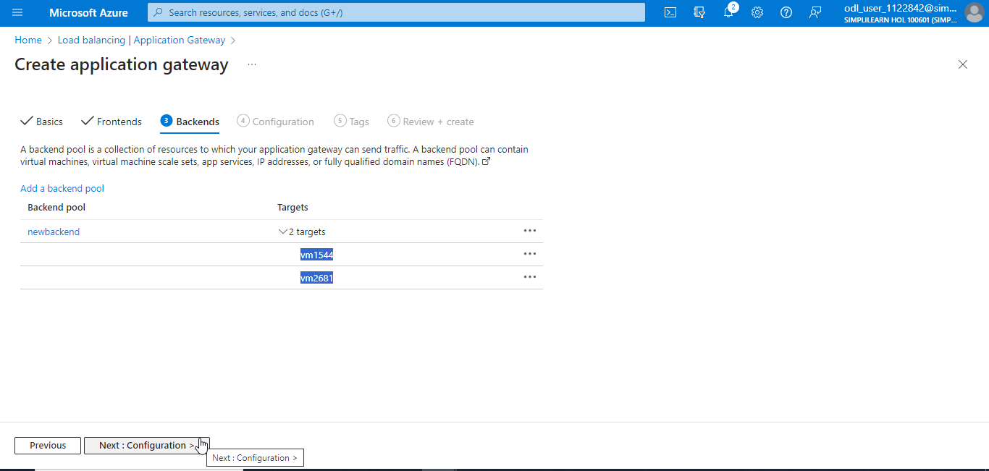

  - In the Configuration tab, click on Add a routing rule

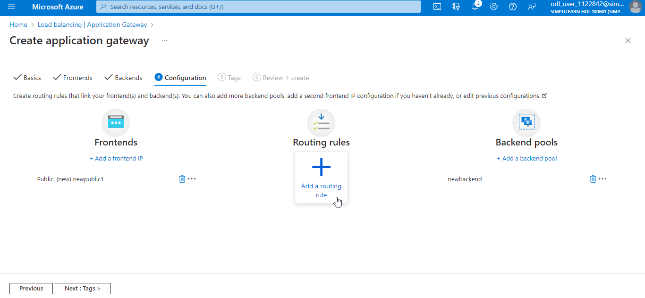

  - In the Add a routing rule section, provide the details as shown in the screenshot below:

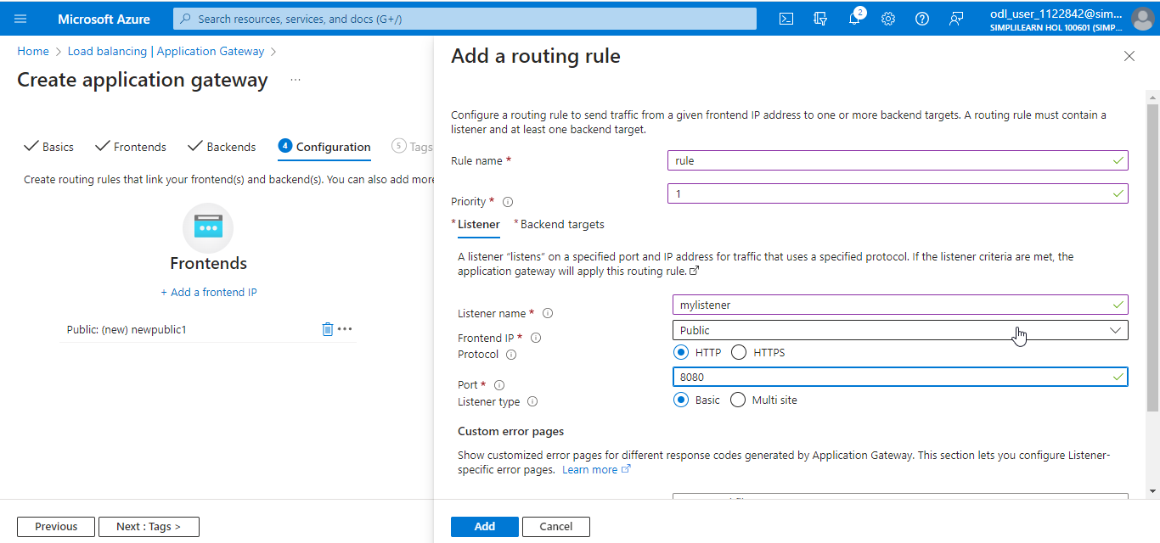

  - Navigate to Backend targets, provide the below details, and click on Add new

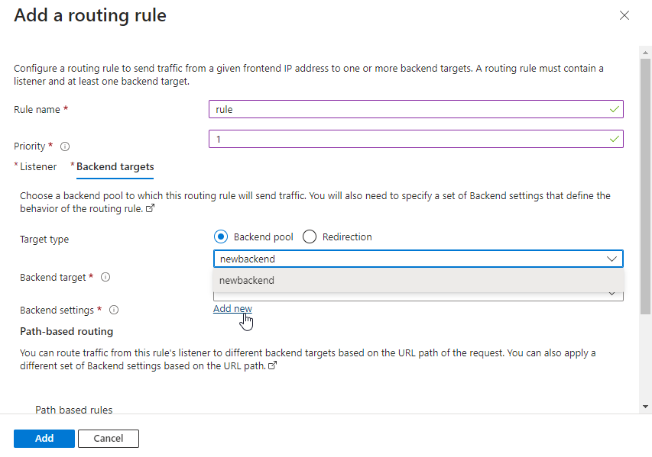

  - In the Add Backend setting, provide the details as shown in the screenshot and click on Add

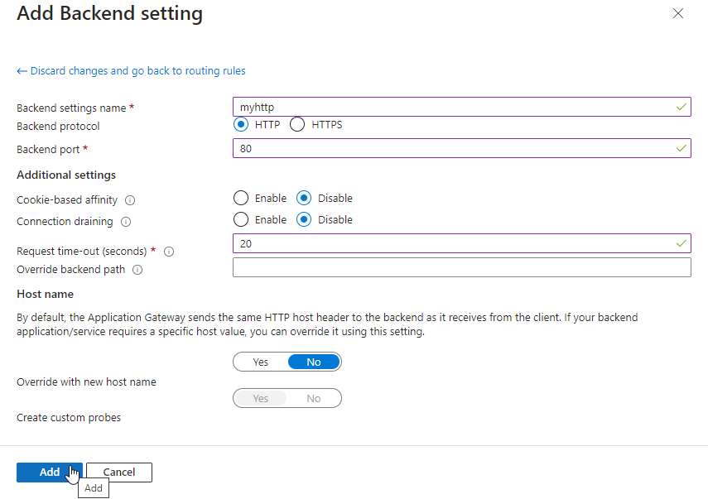

  - In the Path-based routing, click on Add multiple targets to create a path-based rule

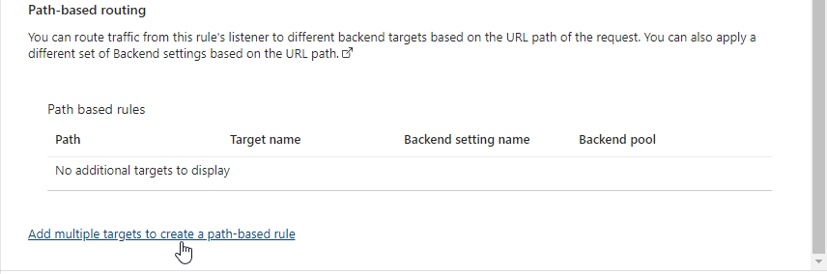

  - On the Add a path page, provide the details as shown in the screenshot and click on Add

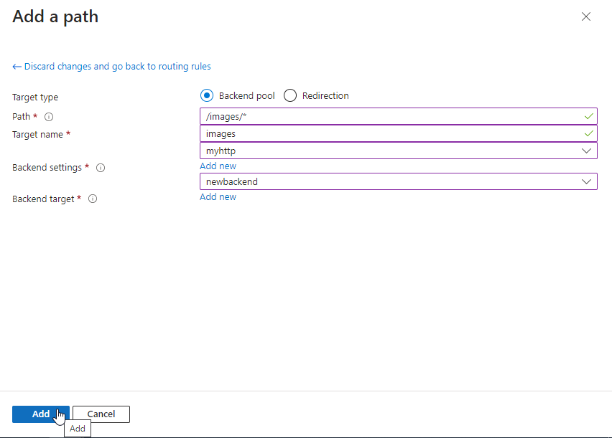

  - Click on Add

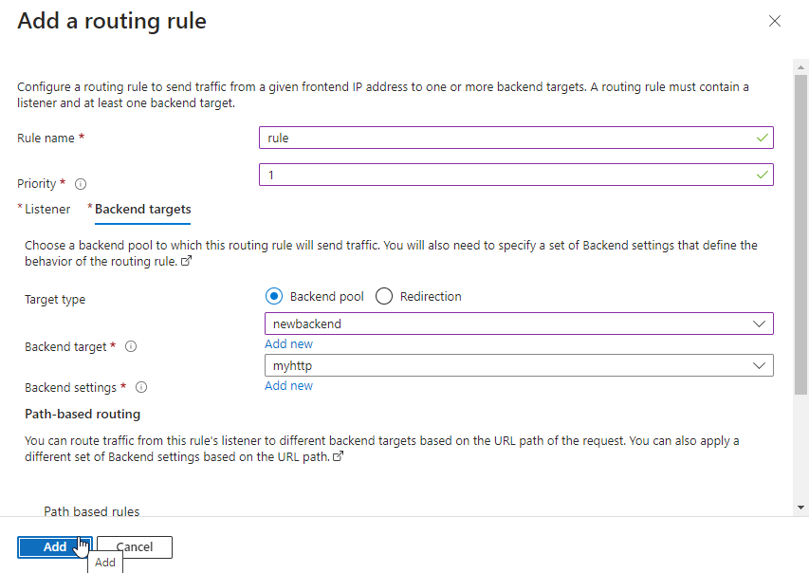

  - Click on Next : Tags >

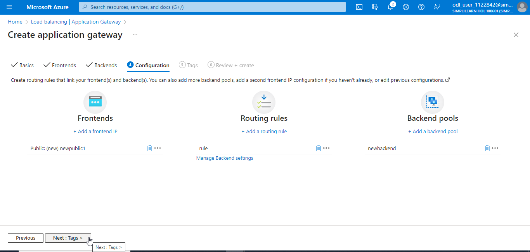

  - Click on Next : Review + create >

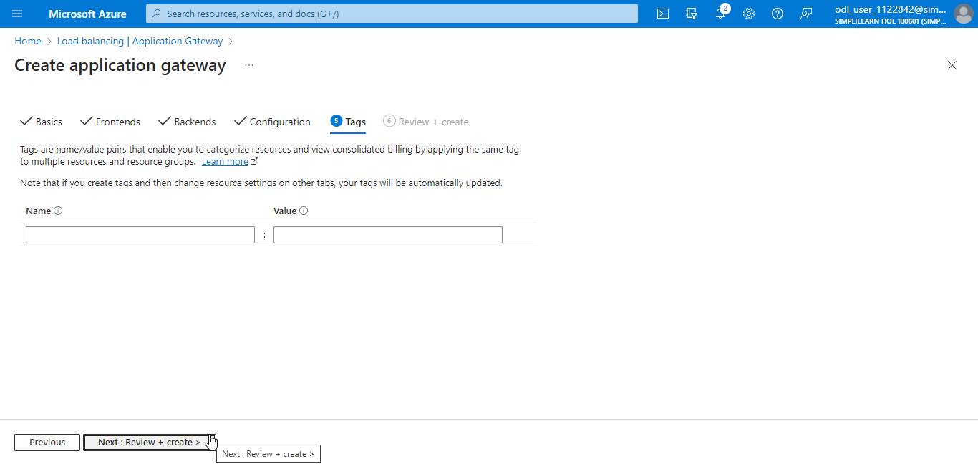

  - After the validation is passed, click on Create

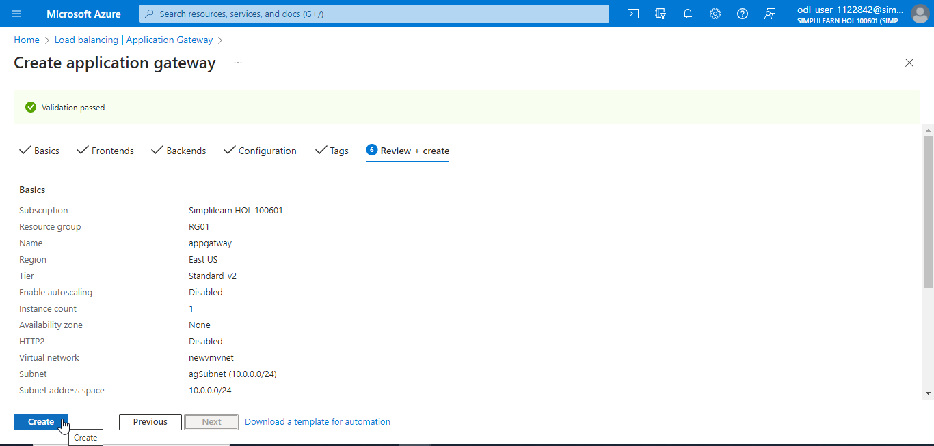

The output will look as follows:

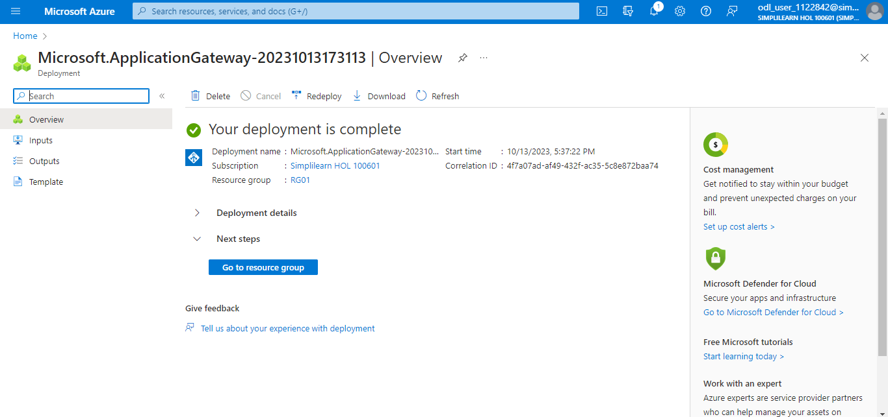

The deployment has been completed successfully.

Step 4: Test the application gateway

  - Navigate to the Application Gateway page and click on the created application gateway

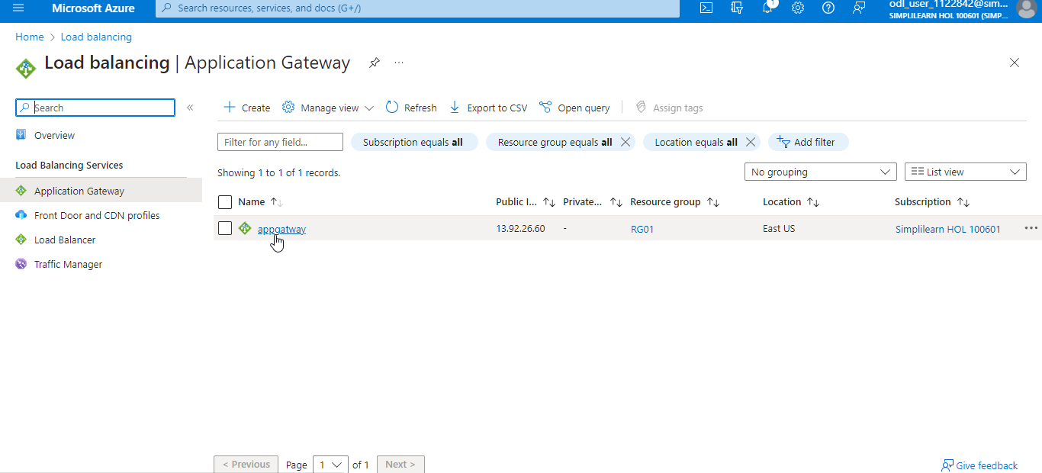

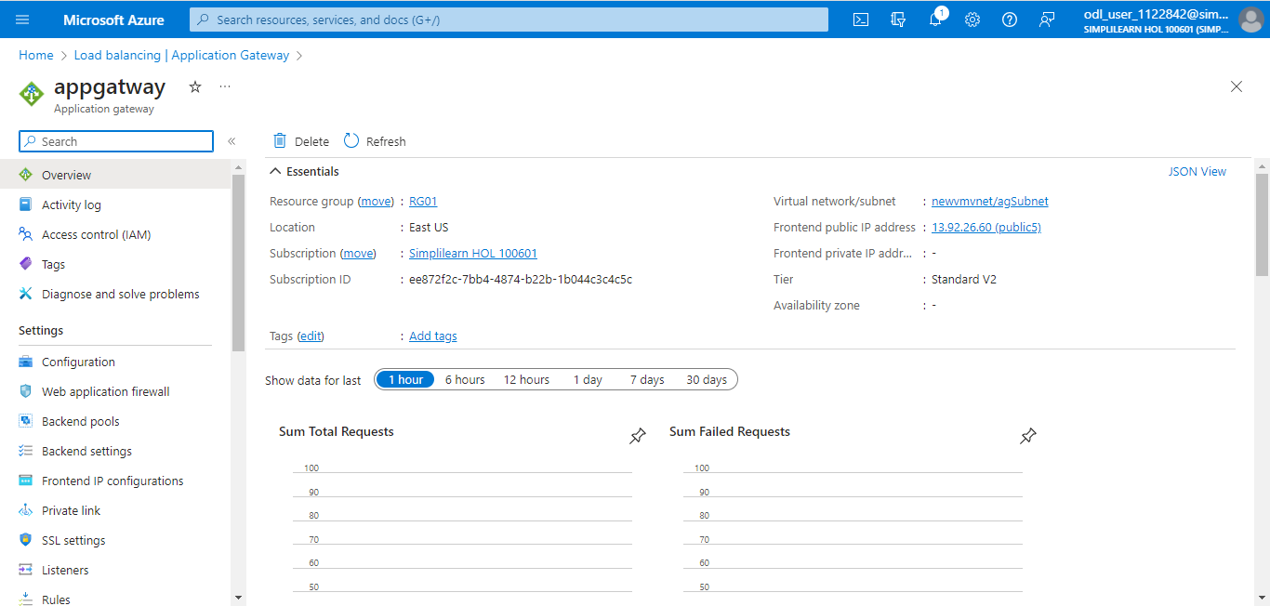

  - Under Monitoring, click on Backend health

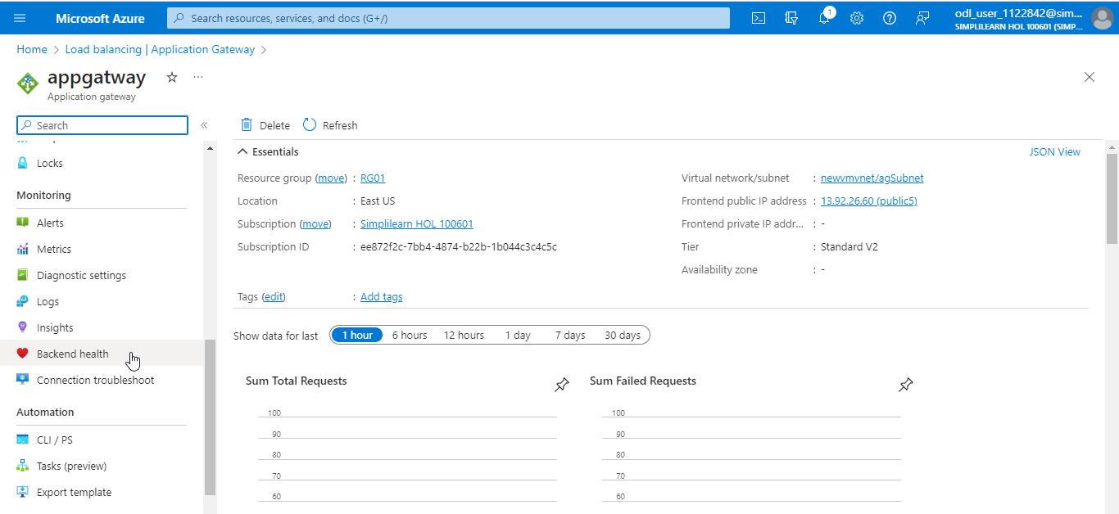

  - Ensure that all the backend resources are in a healthy state

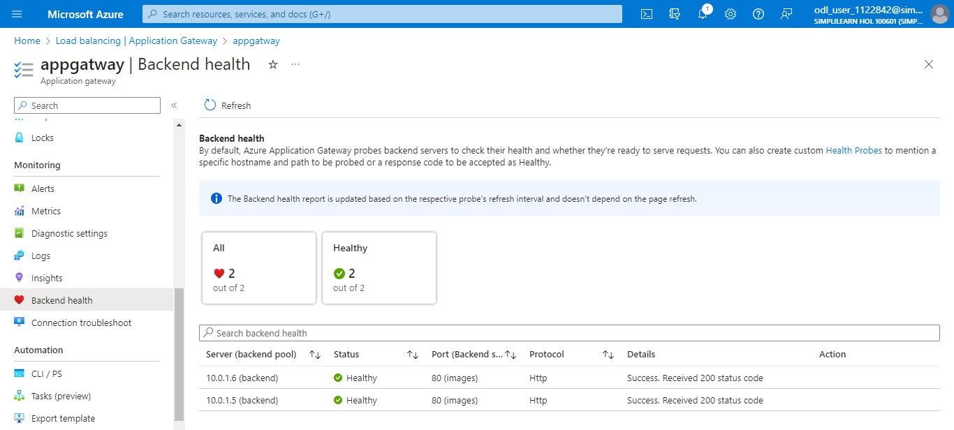

With this, you have successfully created an application gateway with path-based routing.

